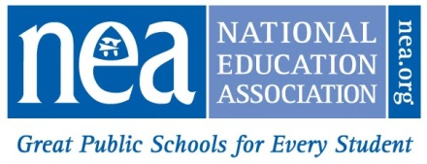
www.nea.org/policyresourcecenter

NEA Resolutions, Legislative Program & Policy Statements
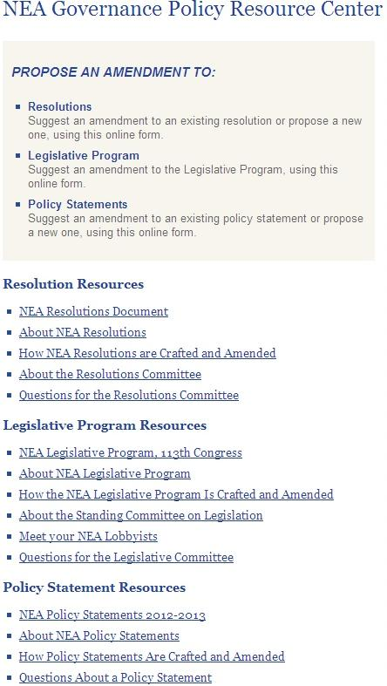
At the flip of a laptop screen, tablet device, or smart phone, NEA members may now take part in NEA’s democratic policymaking processes through an easy-to-access tool on NEA.org. The Policy Resource Center provides members with an opportunity to read, research, and propose amendments to each of the three major policy documents adopted annually by the Representative Assembly—NEA Resolutions, the Legislative Program, and the Association’s six Policy Statements.
Visit www.nea.org/policyresourcecenter to find and share information on these national policy documents and how they are crafted and amended, submit an amendment to an existing resolution or propose a new resolution, submit an amendment to the NEA Legislative Program, or to an existing NEA Policy Statement.
Members may also download the policy documents, read about how each policy is crafted and amended, and engage committee representatives by sending questions to chairpersons and supporting NEA staff.
NEA staff verify the membership status of all persons who use the Policy Resource Center to formally submit amendments or send questions. After verification, each submission is then routed to the appropriate committee for handling.
While the Policy Resource Center is accessible throughout much of the year for all members, open hearings on Resolutions, the Legislative Program, and proposed new Policy Statements (if any) at the Representative Assembly in Atlanta, GA, provide an additional opportunity for elected NEA delegates to meet their committee representatives and participate further in the Association’s policymaking processes.

The NEA Resolutions and Legislative Committees may periodically consider proposed amendments to Policy Statements during the course of their regular committee work. Amendments that are approved by either committee are recommended to the NEA Board of Directors for its consideration in advance of the Representative Assembly, or to the NEA Committee on Constitution, Bylaws, and Rules for consideration at the Representative Assembly.

